 | Monday, April 13th | Tuesday, April 14th | Wednesday, April 15th | Thursday, April 16th | Friday, April 17th
Math | Please watch the “addition key words” instructional video. This will be assigned on Seesaw.  Sign into SeeSaw using your Classlink login or QR code. Go to the activities tab and find the assignment below.  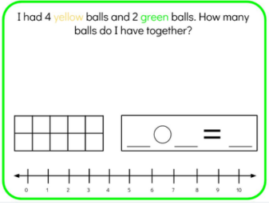 | Please watch the video “Addition Word Problems Strategy” instructional video. This will be assigned on Seesaw.  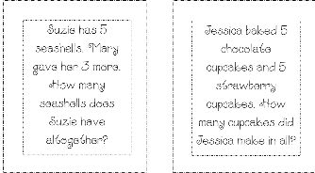Choose 6 flashcards from the attached packet in your email. For those 6 flashcards, practice circling the numbers and the addition key word and practice writing an addition number sentence. Then, using the last page of the packet, choose one of the 6 flashcards you practiced with to solve the addition number sentence using the different strategies.  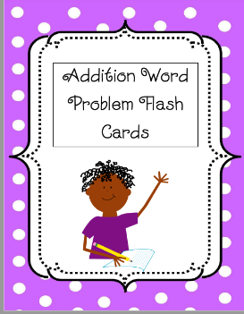 | Please watch the “Addition word problems” instructional video. This will be assigned on Seesaw.  Sign into SeeSaw using your Classlink login or QR code. Go to the activities tab and find the assignment below.  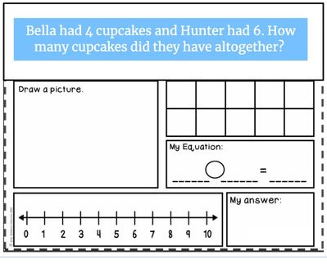 | Review the addition key words anchor chart. This will be assigned on Seesaw.  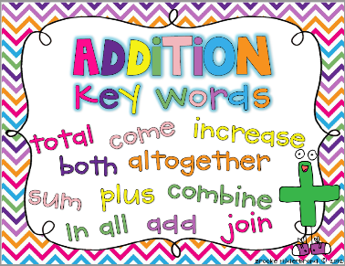  Complete one of the addition sheets (peaches, chicks, or ice cream). Identify the addition key words you hear and solve the addition problem using the number line, by drawing a picture, showing it in the ten frame, and writing an addition number sentence.  This will also be an attachment in your email.  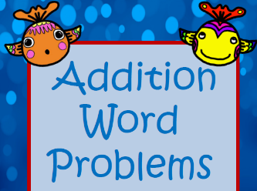 | Review the “Super Story Problem Lesson” Powerpoint. This will be assigned on Seesaw.  Use supersonic vision to zoom into the word problem. Try to find the key words and eliminate the extra information to solve the story problem that is an activity on seesaw  Sign into SeeSaw using your Classlink login or QR code. Go to the activities tab and find the assignment below.  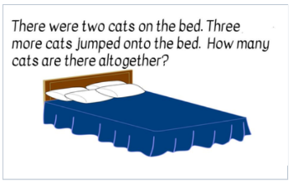
Reading/Phonics | Reading:  When we read a fiction book, we can identify the characters in the book. Choose a picture book. Read the book or have someone read it to you. Then do the following:  -Identify the characters. -Draw a picture of the characters in the book.  -Label the characters.  -How you would describe the characters?  -Draw “thought bubbles” for the characters to show what the characters are thinking or feeling.  Post to Seesaw when finished.  Phonics:  Find the phonics activity on Seesaw for Magic E. Watch the video and then have your child read the CVC words. They will add the Magic E and then rewrite the new word. Don’t forget to record them reading the new words :) | Reading:  Informational books have vocabulary words that are related to the topic. One way to figure out the meaning of a word is to look at the pictures on the page. Readers then think, “Does this picture help me figure out this word?”  Login to RAZ kids and choose an informational book to read. While you are reading, pay attention to the words that are related to the topic.  ▪ Look at the pictures on the page to see if you can figure out what the word might mean.  ▪ Think about all the words that you are learning about the topic. ▪ Use the words to tell someone all the new information that you learned about the topic.  Phonics:  On Seesaw, find the activity titled “Phonics 4/14/2020”. Watch the video and then spell out the Magic E words to match each picture. Record yourself reading the words. | Reading:  Login to RAZ kids and choose a book to read. As you read, pay attention to the characters (the people or animals), the setting (where the story takes place), and the major events (all the things that happen). Read, or have someone read to you, a picture book. Retell the story. Remember to talk about:  ▪ The characters: Who are they? How would you describe them?  ▪ The setting: How would you describe it?  ▪ The major events: What happened throughout the whole story?  Phonics  Watch the Silent E video on BrainPop Jr. (This can be found on Classlink)  https://jr.brainpop.com/readingandwriting/phonics/silente/  Then take the “Easy Quiz”. | Reading:  Login to RAZ kids and choose an informational book. Then:  - identify the author (the person who wrote the book)  - identify the illustrator (the person who drew the pictures)  - look at the front cover, the back cover, and the inside cover (if it is a hardback book). Think about what the main topic of this book will be. What will you learn?  Read the book and then talk about: What was the main topic? What details did you learn about this topic? Now that you have read about the topic, what do you think?  Phonics  Play the Make a Word Game on Starfall:  https://www.starfall.com/h/ltr-lv-a/maw-a-e/?t=291658545 | Reading:  Practice your Sight Words!  Here are some fun ideas to work on your “snap” words!  - Rainbow  - Chalk  - Shaving Cream  - Magnet Letters  Challenge yourself! Try using the words in sentences.  Phonics  Make your own Magic E wand to create new words!  You can use anything you have around the house: paper, pipe cleaners, popsicle sticks, straws, spoons, etc. To make your wand. Write these words on a piece of paper or note cards and read them with and without the Magic E on the end and see how the vowel sound changes!  Hop  Mad  Can  Van  Pan  Rid  Tap  Rat  Bit  Hid  Rob  Kit  Cap  Tub  Cub  Fin  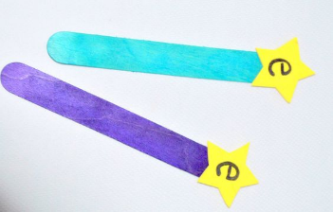  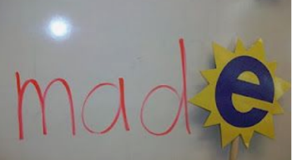
Writing | We are going to begin a new type of book – All About Books. Go on a search around your house or outside and look for things you know about. Take a picture of two things and post them on Seesaw. | Did you know scientists can be writers, too? What scientists write, they start by drawing detailed pictures and labeling important parts to teach others. Draw a detailed picture and add labels to teach about one of the things you found yesterday. | Watch the video on “How Scientists Observe and Learn” Draw and label another picture with the other thing that you found on Monday. When you finish, post it on Seesaw. Remember to observe like a scientist! | Today, you are going to start an “All About” book by making an eye catching cover! You can write about one of your things from earlier this week, or start on a new topic.  Make sure to include a title, your name, and a picture! | We are going to keep working on our All About book from yesterday. Today, we will make an introduction page to hook our readers! Draw a picture of your topic and include a seence or question to get your reader’s interest!
Science | Go onto BrainPop Jr. through Classlink and watch “The Lifecycle of Plants “  https://jr.brainpop.com/science/plants/plantlifecycle/  Take the easy quiz at the end. | Sign into SeeSaw using your Classlink login or QR code. Go to the activities tab and complete the assignment below.  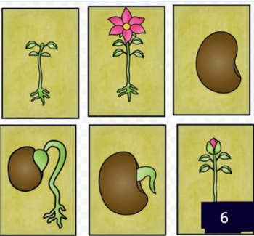 | Grow a Bean in Bag Experiment:  Materials Needed:  - A plastic zip top baggie  - One paper towel  - A few beans (any kind)  Directions:  First, fold up the paper towel so that it will fit easily inside the plastic baggie.  Next, wet the paper towel and place at least two beans inside.  Then, put the wet paper towel into the ziploc bag.  Finally, observe for 3-5 days  On a separate sheet of paper, write your prediction of what you will think will happen or what will happen to the bean over time. | Go onto Brainpop Jr. Through Classlink and watch “The Lifecycle of the Butterfly”  https://jr.brainpop.com/science/animals/butterflies/  Take the easy quiz at the end. | Go to the GA aquarium or the Atlanta Zoo website and go on a virtual field trip.  There are many different cameras that you may look at to see what the animals are doing.  Activity: Have fun exploring these wonderful cameras that show animals and sea life.  GA Aquarium:  georgiaaquarium.org  Zoo Atlanta  zooatlanta.org
Additional/Optional | 20 minutes of iRead/20 minutes of iReady Math | 20 minutes of iRead/20 minutes of iReady Math | 20 minutes of iRead/20 minutes of iReady Math | 20 minutes of iRead/20 minutes of iReady Math | 20 minutes of iRead/20 minutes of iReady Math
- Please note that you have different options when turning in assignments. You may turn them in via a picture or video through email, on seesaw, or when you return.
- If you choose to post your completed work on seesaw you will do the following steps.
- Scan the class QR code provided by your teacher (this is different from the parent QR code )
- Once you scan the QR code you may upload your child’s work, there is a youtube link below that you may view to help or use the attachment directions
- The highlighted activities are the ones that will be taken for a grade. *Note: If you are having trouble viewing the highlighted activities, try opening it on a different device. Some devices will not show the highlighted activities.

